Smithfield Public School Preschool
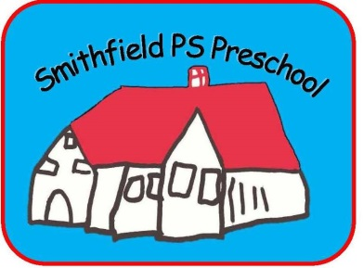
O'Connell Street
Smithfield 2164

Preschool Phone: 9725 3243 (Before 9.00am)
School Phone: 9604 5475

Fax: 9725 5648

Before & After School Care: 9604 8348
School Email: smithfield-p.school@det.nsw.edu.au
Preschool Email: smithfieldps.preschool@gmail.com

School Principal | Jodi Harris (Relieving)
Preschool Supervisor | Arti Singh
Preschool Teachers | Mariela Silvera  Joanne Haikin  Christian Pagano
School Learning Support  Officers (SLSO) | Goidana Stone  Priscilla Fasavalu

The Preschool operates on a 2 or 3 day attendance program.
Children enrolled will attend:

Possum & Emu Terms 1 & 2 Monday, Tuesday : 9:00 am – 3:00 pm
Terms 3 & 4 Monday, Tuesday, Wednesday: 9:00 am – 3:00 pm

OR

Koala & Wallaby Terms 1 & 2 Wednesday, Thursday, Friday : 9:00 am – 3:00 pm
Terms 3 & 4 Thursday, Friday : 9:00 am – 3:00 pm

Pedestrian Entry from Horsley Drive

Dear Parents

Welcome to Smithfield Public School! We greatly look forward to your child beginning their first step into formal education at our preschool. The educational program here is simply excellent. It provides opportunities for the development of creativity and imagination as well as the practical skills of social and academic (literacy and numeracy) endeavours.

Our teachers and support learning officers are caring, capable and very experienced practitioners. They understand and love young children.

As the first teachers of children, parents are welcome to participate in the learning of their children. Please keep an ‘eye out’ for the many activities and opportunities we will provide.

We welcome you to the Smithfield P.S learning community.

Best wishes

Jodi Harris
Relieving Principal

Smithfield Preschool Educators

Teachers
Mrs. Mariela Silvera  Emu and Wallaby  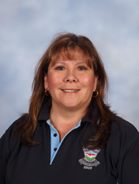  - Diploma of Teaching (Early Childhood).  - Has worked at Smithfield Public School Preschool since 1995 | Mrs. Joanne Haikin  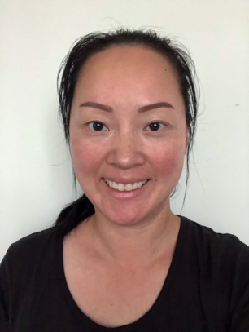  Possum  - Bachelor of Education (Early Childhood).  - Been teaching since 2004  - Has Reading Recovery and K-2 experience |  | Mr. Christian Pagano  Koala  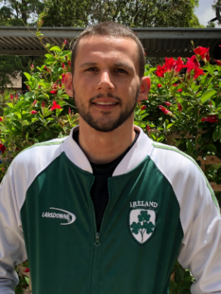  - Master in Teaching (Primary)  - Diploma in Early Childhood  - Has been teaching since 2012  - Has experience teaching K-6
School Learning Support Officer (SLSO)

Mrs. Goidana Stone  Emu and Wallaby  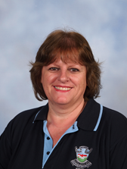  - Cert III in Early Childhood Education and Care  - First Aid Certificate – HLTAID004  - Has worked at Smithfield Preschool since 1994 |  | Mrs. Priscilla Fasavalu  Possum and Koala  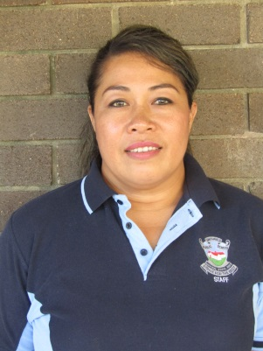  - Diploma of Early Childhood Education and Care  - Currently studying Bachelor of Education (Birth to 5 years old)

Our Preschool Philosophy

We believe in acknowledging the original custodians of this land, the Darug people and their language and all Aboriginal and Torres Strait Islander people in the community.

At Smithfield Public School Preschool our philosophy is our vision and beliefs about how children learn. It is based on the Early Years Learning Framework for Australia-Belonging, Being and Becoming. Our Philosophy is seen as a living document, continually evolving in the light of new research, the ideas of team members, children and input from families. It is the foundation for our decision making in providing quality care and education for children.

The early years of a child’s life are the most important learning periods in their development. We believe that all children are individuals, bringing a unique set of abilities, values, attitudes, interests and experiences to the learning situation. We acknowledge the importance and privilege of our role as early childhood educators in supporting, nurturing and facilitating growth and development of all children and shaping future citizens of the world.

We believe that children learn best through play. We see play as a vital part of our preschool program. Play provides children with the opportunity to learn, create, imagine, discover, problem solve, role play and explore. Educators provide these opportunities through planned intentional teaching, direct hands on exploration and rich learning environments that cater for each individual child’s needs, strengths and interests. Learning is child centred and driven and educators support and facilitate learning by encouraging students to direct their own learning which challenges them to engage in critical thinking and problem solving skills. This deep inquiry based learning fosters independence, confidence and a positive self concept.

We believe that it is important to establish a professional culture of reflective practice, one where ongoing professional development for educators is supported and encouraged, an environment where there are high expectations for the quality of the educational program and a mutual respect between families and educators as we work together to ensure a positive start in the early years for preschool children. We value the importance of families and the wider community in the lives of each child. We also value the diversity of cultural backgrounds which the children bring with them, and aim to include aspects of their cultures in our program. We also aim to provide a link to information and support services available in our community for our families.

Smithfield Public School Preschool believes it is important to provide indoor and outdoor spaces which encourage children to develop an appreciation for sustainable practices, respect for the natural environment and to promote children’s understanding about their responsibility to care for the environment through sustainable practices. Our community also believe that it is important to provide a balance of learning opportunities and experiences to cater for all learning styles and stages of development such as structured, unstructured, creative, informative, individual and group learning experiences for all children.

We believe that teamwork is an important part of our preschool setting and work to build an honest, open and non-judgemental relationship between all staff, families and the children in our care.

Revised 2018

Activities/Performances
Incursion
There will be an incursion each term. There is a cost attached to these activities. ‘Chicks R Us’ and ‘The Reptile Man’ have already been booked for next year.

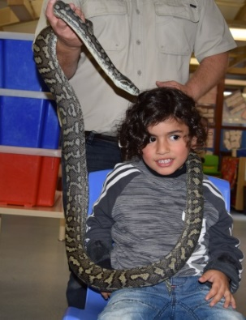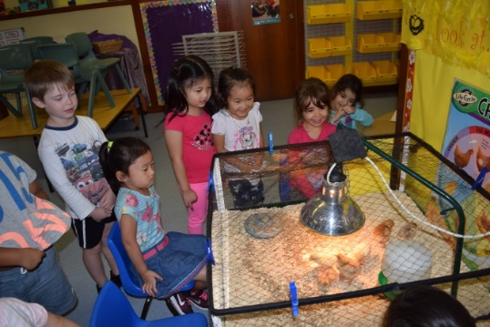

Excursion

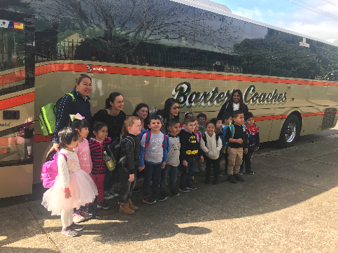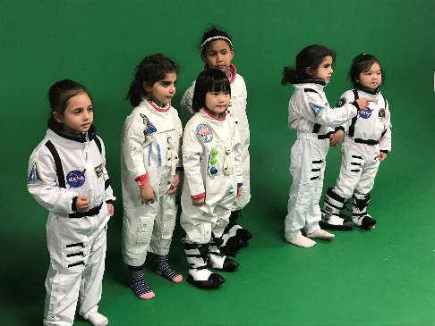

There will be one excursion in term 3. Each year we visit a venue which is linked to our learning. In 2018 we visited the Powerhouse Museum which extended our interest and learning of Space. Parents will need to pay for the bus and venue.

Arrival/Departure:
The Preschool hours are the same as the rest of the school, 9am till 3pm. For safety reasons, children must be brought to and collected from preschool, by a parent, carer or other responsible adult. Children must be signed in and signed out every day. Children must not be left in the grounds without supervision. If you have an older child at the school, it is best to drop them off first then bring your pre-schooler and in the afternoon, do the reverse, i.e. pick up your pre-schooler first and then collect your K-6 child. Please be prompt when collecting your child. Children can feel isolated when they are the last one to leave. Please ring the preschool on 97253243 to let us know if you are running late. After 3.15pm your child can be collected from the school office.
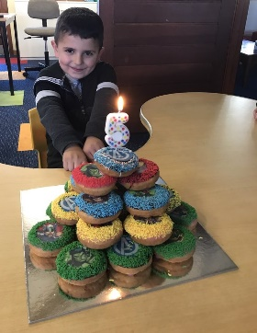
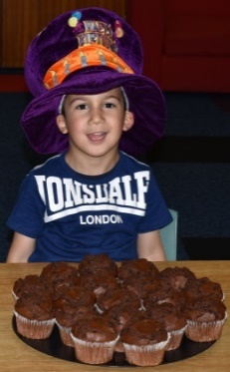
Birthdays:
We love to celebrate the children's birthdays at preschool.
You can bring:
20 cup cakes, or donuts or a large plain cake for 20 children.
Please discuss your plans with your child’s teacher prior to the day.
NOTE: Please avoid nuts due to allergies.

Contact Details:
It is important to keep the school informed of any change of home address and contact telephone numbers (including work numbers) so that immediate contact can be made if necessary.

Emergency/Evaluation Drills
An evacuation procedure is displayed in the preschool. Staff and children practise evacuation and lockdown drills on a regular basis (once a term).

Fees:
Preschool Fees are $20 per day or $10 per day if you have a Health Care Card.
A payment schedule will be given to successful applicants.

Fees are to be paid weekly or in advance
at the school office

You are required to pay fees, whether or not your child is in attendance, to keep his/her place. If you have a problem paying fees you are asked to discuss this with the principal.

Health/Hygiene:
Please dress your child in play clothes that are comfortable, easy to wash and manageable for your child e.g. track suits with sleeves that are easily pushed up. For safety reasons, joggers should be worn when climbing on the fort. Please do not send your children in thongs or shoes without a strap at the back of the foot. Belts and braces are also difficult for children to manage. All paint should come off clothing if sprayed with Preen.

Children will be free to go to the toilet whenever they wish, so please encourage them to do so and to use the toilet independently and sensibly. Constant reminders about toilet flushing and hand washing are still necessary. Children must be independent with toileting before starting preschool.
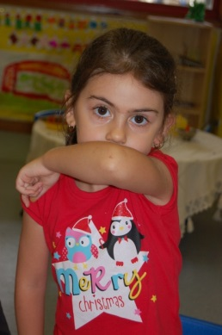
Please help us by teaching your child to

- Use the toilet correctly and regularly
- Wash hands after using the toilet
- Independently blow/wipe their nose, put all tissues in the bin and wash hands
- Cough or sneeze into their inner elbow

Illness:
When children attend preschool their exposure to infectious conditions may be increased. Young children have age-characteristic behaviours that may contribute to the spread of infection and need guidance and support to develop good hygiene habits such as washing and toileting skills. The spread of infection is a major issue in early childhood services. In order to minimise the spread of infection, children suffering from certain infectious diseases are excluded from attending preschool.

The NSW Health sets guidelines on infectious diseases and exclusion times from preschool attendance. The Smithfield Public Preschool will abide by these for all cases of illness whether child or staff.
(visit the website www.schoolatoz.nsw.edu.au/wellbeing/health/too-sick-to-go-school for SOME INFECTIOUS DISEASES of CHILDREN for EXCLUSION PERIODS for VARIOUS ILLNESSES.)

In the interests of other children and staff we ask that your child not attend the centre if he/she has:
- Diarrhoea: a child who has watery stools should not return to the centre until he or she has been free of the diarrhoea for 24 hours. If the child has an allergy or medical condition, which regularly causes diarrhoea, please discuss this with staff on enrolment.
- Vomiting: a child who is vomiting should be kept at home for a period of 24 hours, after the vomiting has stopped. Micro-organisms which cause vomiting and diarrhoea are highly contagious and will spread to others very quickly.
- Chicken pox
- Conjunctivitis
- Consistently high temperature
- Excessive discharge from eyes, ears or nose
- Head lice
- Impetigo (if not able to be covered)
- Measles
- Mumps
- Productive cough (ie: bringing up mucous)
- Ring worm (if not covered)
- Rubella (German measles)
- Scabies
- Tonsillitis
- Whooping Cough

If you suspect that your child has an infectious condition, or the early symptoms of illness, they should be kept home until you have had them checked by your doctor. If your child is suffering from an infectious disease it is important that you inform the centre so other parents can keep a watchful eye on their children.
A doctor’s clearance certificate will be required before re-admission to preschool.
Please note: There is a 24 hour exclusion period from the last attack of diarrhoea or vomiting (This is a NSW Health requirement).

Children who become unwell at school are best cared for by parents. If a child becomes ill while at school, the parent(s) or carer(s) will be contacted and asked to collect the child. The wellbeing of children is the highest priority in the preschool. We realise that it is especially difficult for working parents when a child is unable to attend, therefore we advise that, at the beginning of the year, an alternative carer be arranged in the event of illness.

The school will keep all parents informed about the occurrence of an infectious disease in families or staff at the preschool by way of a notice at the sign on/off book or letters provided by The Department of Health.

It is in the interest of all the children that a sick child is kept at home or with another adult who is able to give them the emotional and physical support they need.

Medication:
No short term medications e.g. antibiotics will be administered by staff at preschool. If your child suffers from asthma or anaphylaxis you must discuss a health management plan with your child’s teacher.

Newsletter:
Preschool is an integral part of Smithfield Public School. We work together as a team to provide an excellent learning program for all children. The school newsletter will be sent home every fortnight and we encourage all parents/carers to be part of the school community and enjoy the recreational and fundraising activities which assist you in building connections and friendships.

Parent Involvement:
Parents are welcome to be involved in the program and spend time with their child in the preschool. It is very important for your child to see your interest in his/her activities. This contributes to a holistic approach to learning where all aspects of the child’s world are taken into consideration.
Learning is a social experience that involves families and the community. If you have a particular skill or interest, such as the ability to play a musical instrument or cook international recipes, please let us know. We would love to expand the children’s experiences in this way. We invite parents to make suggestions for the children’s programs and lessons.
We, as a staff, recognise that parents know their children best. Your communication with us is greatly valued. Should you wish to discuss any matter regarding your child’s progress and development, please do not hesitate to speak to your child’s teacher.

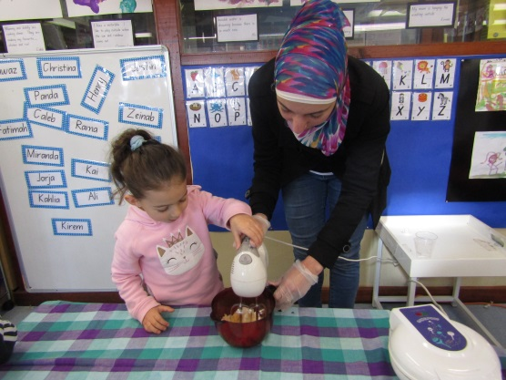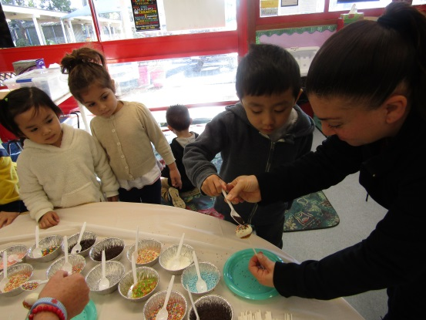
P&C:
Parents are welcome to join the P&C and all parent workshops. P&C meetings are held on the second Monday of each month at 9.15am. Notifications in the newsletter.

Parking:
PARENTS ARE NOT PERMITTED TO DRIVE INTO THE SCHOOL GROUNDS TO VISIT THE PRESCHOOL OR PARK IN THE PRIVATE DRIVEWAY ADJACENT TO THE PRESCHOOL. This is a dangerous practice and could cause an accident.
Parking is available on O’Connell and Neville Streets.

The Horsley Drive gate will be locked from 9:30am-2.30pm. Entry is available through the school entrance in O’Connell Street between 9:30am – 2:30pm.

Preschool T-Shirts:
Parents can provide t-shirts or sloppy-joes (cotton/polyester) to be printed with the preschool logo. Cost of printing will be advised early in Term 1.

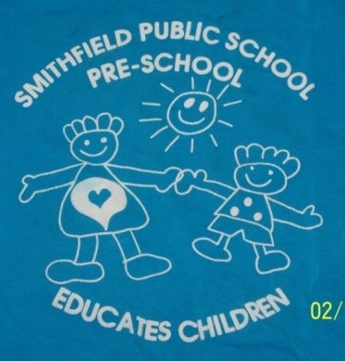
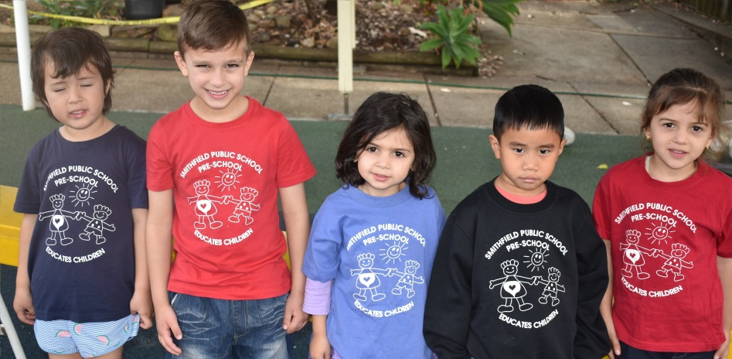

Program:
Our preschool program is based on the EARLY YEARS LEARNING FRAMEWORK.
The daily program is designed to meet the needs and interests of every child, recognising that all children develop at different rates. Our program is based on play as this is the way most humans, but especially children, make sense of their world.
PLAY IS CHILDREN’S WORK

Munch and Move Program
Munch and Move is a fun, play based program that supports healthy development of young children. Educators will encourage children’s healthy eating and physical activity. This program supports early childhood services to develop and implement policies and procedures that promote healthy eating, the development of fundamental movement skills and limit small screen time. We look forward to working together with families to implement “Munch and Move” at preschool and at home.

Portfolios:

In 2018 preschool will use electronic portfolios through ‘Seesaw’. Parents will be able to view children’s activities. Children’s work will also be sent electronically to families. Free app can be downloaded from the App Store or Play Store.

Please have a current email address available to give to your child’s teacher in order to access this app.

Requirements:
Every day your child will need to bring to preschool:

A piece of fruit, vegetable, cheese or yoghurt and a bottle of water for morning tea.

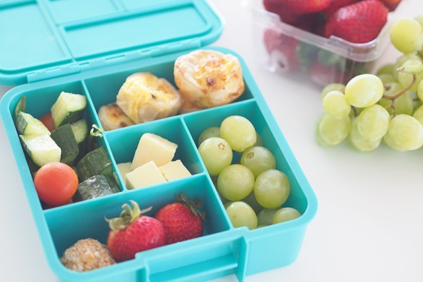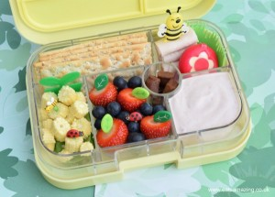

A healthy lunch and a drink (water only).

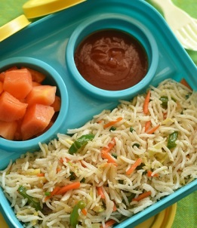
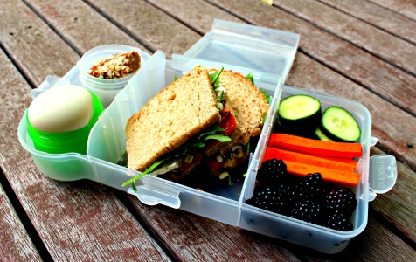

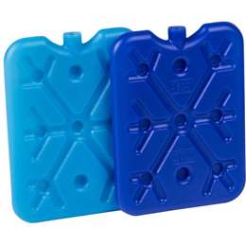
Lunch can be ordered from the school canteen. Please let your child’s teacher know when you have ordered from the canteen. A special preschool menu will be distributed at the beginning of the year. No hot food to be ordered.

Please pack an icepack with your child’s lunch box each day.
PLEASE NOTE: WE ENCOURAGE A NUT FREE ENVIRONMENT

PLEASE DO NOT SEND LOLLIES, CHOCOLATE BARS, CHIPS, CORDIAL OR FIZZY DRINKS.
We encourage the children to develop healthy eating habits.

Please provide your child with healthy everyday food options.

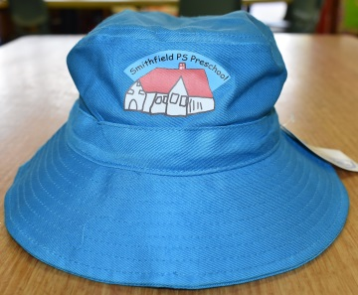
A bucket hat or legionnaire cap for outside play. The preschool supports a "No Hat No Play" policy. Children without a hat will be encouraged to play in a shady area.

Bucket hats with Smithfield PS Preschool’s name will be available for purchase for $10 at orientation and in 2019.

A spare set of clothes (seasonally appropriate). Not just for toileting accidents, but also when your child has fun with messy activities such as water play.

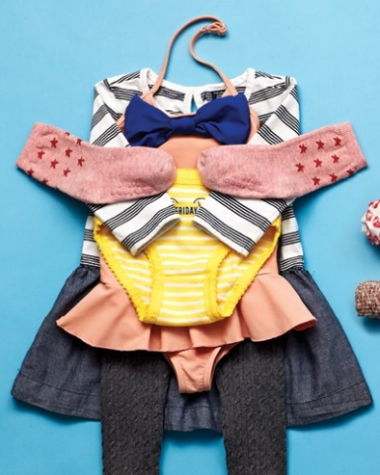

Due to our sun protection policy children must have their shoulders covered. No sleeveless tops, dresses or singlets please.

Shoes with velcro straps  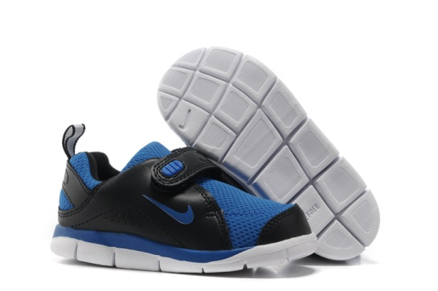 | No clogs or shoes without a strap around the heel.

A SCHOOL BAG large enough for children to be able to unpack and pack themselves.

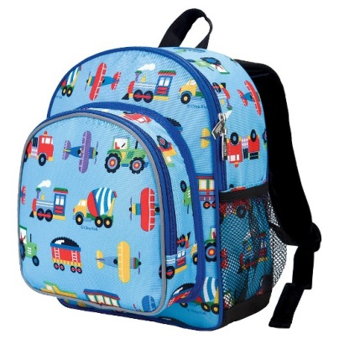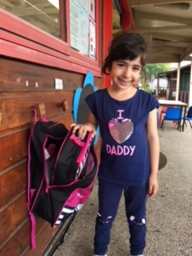

Please ensure that a lunch box, spare clothes, hat and a drink bottle fits into the bag.

PLEASE LABEL EVERYTHING YOUR CHILD BRINGS TO PRESCHOOL WITH HIS/HER NAME. Children do not always recognise their belongings in an unfamiliar environment and your child may have the same lunch box/drink bottle as another.

You will also be asked to provide each term

A box of tissues. | A library bag (available from preschool or from the uniform shop in the school hall).  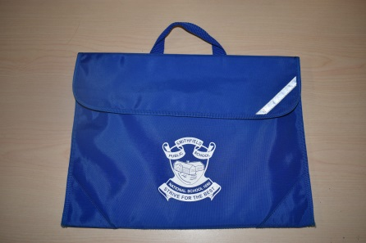
A packet of fragrance free baby wipes or antibacterial wipes.  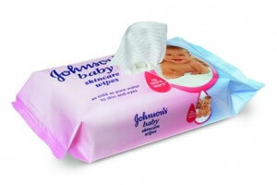 | All pictures are available to be viewed on ‘StoryPark’ all year, it can be saved from your computer or iPad. If you do not have access to Storypark and wish to have your pictures saved onto a USB please bring in a 8GB USB attached to a key tag (optional).  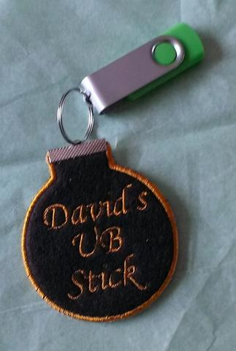

Rules
The preschool children will contribute to the development of the preschool
expectations based on the Smithfield Public School Rules of being a Safe,
Responsible, Respectful Learner.

We help children to understand that rules are necessary when they are together in
a group. The limits we set are concerned mostly with physical safety e.g. care when
climbing, no capes on the slippery dip, no bikes at the top end of the playground, care
of equipment and respect for other children and adults.

We help children to learn by example and to understand the reasons for setting
particular limits. We use a positive behaviour for learning (PBL) which is a whole school process to improve learning outcomes for all students P-6.

Toys from home are difficult for us to care for and are often difficult for children to
share amongst a large group. If you have something you would like to share with us
please discuss it with the teacher the day before. If it is your child’s birthday he/she
may bring a toy to show as a special treat, but otherwise, please do not let your child
bring toys to preschool.

Sun Safety

Teachers will encourage the development of positive attitudes towards sun protection and also towards lifestyle practices that can help reduce the incidence of skin cancer.
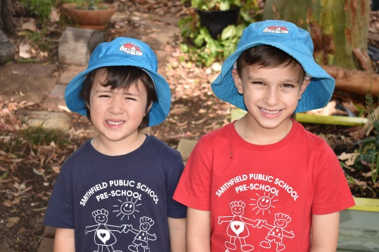
All children are required to wear a protective hat whenever they are outside. Children should also wear their hat on arrival and departure from the preschool to develop healthy sun safe habits.
Staff and children wear sun safe hats that protect
their face, neck and ears.
A sun safe hat is a:
- legionnaire hat
- bucket with a deep crown and brim size of at least 5cm (adults 6 cm)
- broad-brimmed hat with a brim size of at least 6 cm (adults 7.5 cm)
When outdoors, staff and children wear sun safe clothing (e.g. dresses with sleeves and collars) that covers as much of the skin as possible (especially the shoulders, back and stomach).
Please note: Midriff, crop or singlet tops do not provide enough sun protection and therefore are not recommended.
The preschool asks parent(s) and carer(s) to assist the children in applying sunscreen before leaving home or at preschool (sunscreen near sign on book) each day. During Terms 1 and 4, the daily activities may begin outdoors to utilise the cooler part of the day.

Use of School Facilities and Resources
As our preschool is part of Smithfield Public School, we regularly use the school facilities, as well as offering a highly successful transition program. Some special links within our school include:

- Visits to both playgrounds,
- Participation in extracurricular activities and excursions on special days e.g. Harmony Day, Easter Hat Parade, Mother’s and Father’s Day
activities, ANZAC and Remembrance Day assemblies
- Visiting performances
- Weekly library sessions in the school library, where children may borrow from a selection of books appropriate to their age and development.
- School newsletters each fortnight
- Access to technology (eg. Smart Board in preschool rooms, iPads, and computers)

Finally:
We hope both you and your child find our preschool a warm and caring place. We want to provide a happy loving atmosphere as a comfortable transition between home and school. Your child will be encouraged, as an individual, in all aspects of his/her development.

Please feel free to come into the preschool to discuss any problems you might have, so that together we will help your child really enjoy this important year, and gain the maximum benefit from it.

www.schoolatoz.nsw.edu.au

School A to Z practical help for parents is a DEC website designed for parents of all
backgrounds. This website answers most parent questions concerning school. All the
information can be translated into several different languages. You also have access
to free APPS and android devices.

http://www.startingblocks.gov.au/
Starting Blocks provides parents with information about early childhood education and care to help them make the best choice for their child and family.

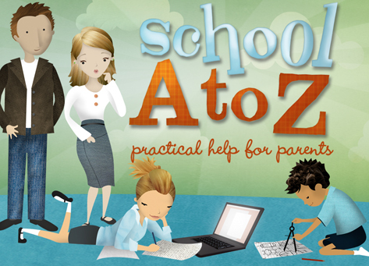

Terms 1 & 4  9.00am: Arrival  - Welcome – Who is here today?  - Outdoor Play – a variety of learning environments and invitations to play in natural outdoor play spaces. Progressive morning tea  - Pack away – Children and teachers do this co-operatively. A valuable time for learning responsibility and organisation.  - Wash hands  - Exploring books  - Language/Story Time - a planned group time of language enriching activities.  - Indoor Play - a variety of learning environments and invitations to play designed to support all aspects of children’s learning and interests.  - Pack away  - Music /Movement - Opportunity for children to explore a range of music and movement experiences.  - Lunch Time  - Quiet Activities  - Library - children visit and borrow books from the school library.  3.00pm Home time  Children share the day’s events, plans for next day.  Children and educators say good bye as individual parents arrive | Terms 2 & 3  9.00am: Arrival  - Welcome – Who is here today?  - Indoor Play - a variety of learning environments and invitations to play designed to support all aspects of children’s learning and interests  Progressive morning tea  - Pack away – Children and teachers do this co-operatively. A valuable time for learning responsibility and organisation.  - Wash hands  - Exploring books  - Language/Story Time - a planned group time of language enriching activities.  - Outdoor Play – a variety of learning environments and invitations to play in natural outdoor play spaces.  - Pack away  - Music /Movement - Opportunity for children to explore a range of music and movement experiences.  - Lunch Time  - Quiet Activities  - Indoor/outdoor experiences supporting children’s interests.  3.00pm Home time  Children share the day’s events, plans for next day.  Children and educators say good bye as  individual parents arrive
An example of Our Daily Routine

